**Team CDA**

**RFP**

**For Sound Sentinel**

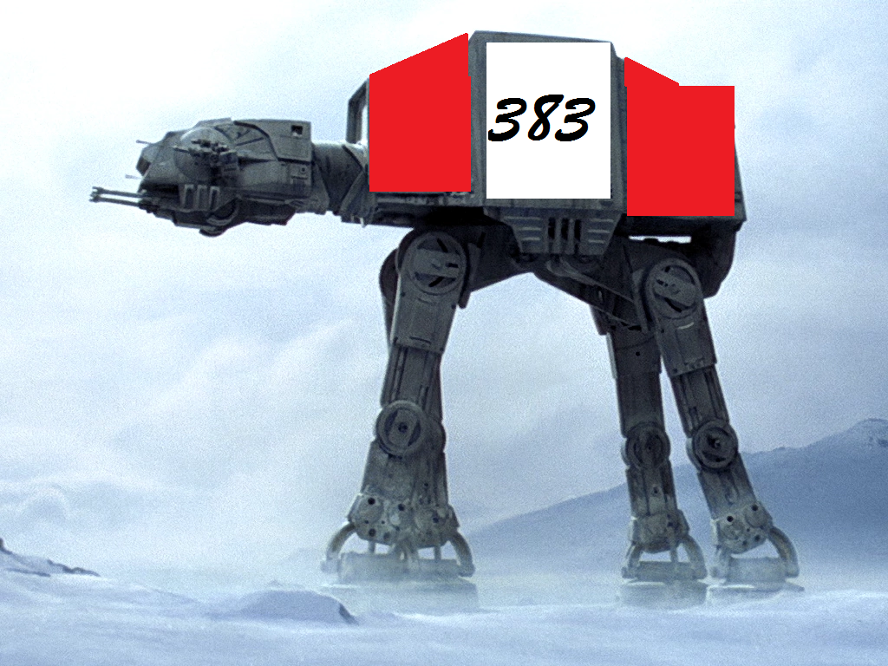

**9-15-2018**

**CDA RFP**

**Table of Contents**

1.0 Problem Description

2.0 Objectives

3.0 Current Systems

4.0 Intended Users

5.0 Known Interactions

6.0 Known Restraints To Development

7.0 Product Schedule

8.0 Glossary

**1.0 Problem Description**

Sound Sentinel will be a video game in a 3D sensory immersive virtual reality environment. The display mimics a full 3D environment so the user can look around in real time. Then projectile balls come at the player, and they must use the controllers to deflect the incoming balls. The balls will have physics properties and can be used to deflect other incoming balls.

**2.0 Objectives**

343 Studios is looking for a vendor to create a three dimensional game for the Vive platform similar in scope to Audioshield, but with the ability to display video, and power point, and PDF within the game.

* The game should have background music and sound effects
* Possibly have bricks that trigger various timed power ups ,user requested, such as larger paddles, invulnerability, and shields
* Save games to an external server
* The more balls you deflect directly or indirectly, the more points are scored. Once you have failed to deflect X amount of balls, the game is over

To increase difficulty:

* Increase projectile count
* Projectiles move at a faster rate
* The angle that projectiles come from increases

**3.0 Current Systems**

University of Idaho Vive station computer

Vive VR system with 2 handheld controllers

Unity 2018.2.7 on Windows

Visual Studio and libraries.

**4.0 Intended Users**

* Dr. BC
* UI students and Den guests
* STEAM users – rated E for everyone demographic

**5.0 Known Interactions**

Unity will provide several of the assets, physics, and libraries needed to make the game functional

STEAM will be used to deploy the game to the public

The game will interact with a server to save scores and rank them

**6.0 Known Restraints to Development**

The game must run on the Vive platform using UIRP-JBeestonPC

This project must be completed before December 6, 2018

Motion sickness and disorientation can be a serious problem in VR games for some users. The game must be designed to minimize these effects by limiting motion that his not initiated by the user.

**7.0 Product Schedule** 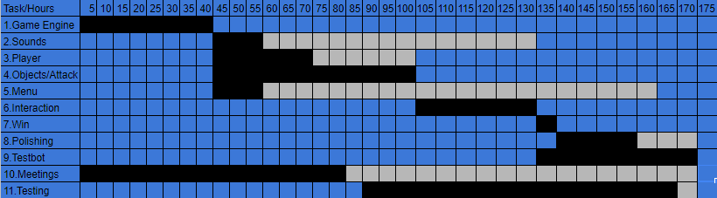

**Dates**

September 18th, 2018 – Proposal Approved

October 4th, 2018 – Initial Release

October 18th, 2018 – Acceptance Testing

November 8th, 2018 – User Training Complete

December 6th, 2018 – Final Release

**8.0 Glossary**

[**VR**](https://en.wikipedia.org/wiki/Virtual_reality) – Virtual Reality

https://en.wikipedia.org/wiki/Virtual_reality

[**Vive**](https://en.wikipedia.org/wiki/HTC_Vive) – Game system platform

https://en.wikipedia.org/wiki/HTC_Vive

[**Visual** **Studio**](https://en.wikipedia.org/wiki/Microsoft_Visual_Studio) – coding environment for C#

https://en.wikipedia.org/wiki/Microsoft_Visual_Studio

[**Unity**](https://en.wikipedia.org/wiki/Unity_(game_engine)) – coding environment focusing on 3D objects and game engines

https://en.wikipedia.org/wiki/Unity_(game_engine)

[**C#**](https://en.wikipedia.org/wiki/C_Sharp_(programming_language)) - Language based on C++ and developed by Microsoft. Used in Unity.

https://en.wikipedia.org/wiki/C_Sharp_(programming_language)

[**STEAM**](https://en.wikipedia.org/wiki/Steam_(software)) – A software deployment program used for games

https://en.wikipedia.org/wiki/Steam_(software)